**Session 19 Assignment 2**

Using udfs on dataframe

1. Change firstname, lastname columns into

Mr.first_two_letters_of_firstname<space>lastname

for example - michael, phelps becomes Mr.mi phelps

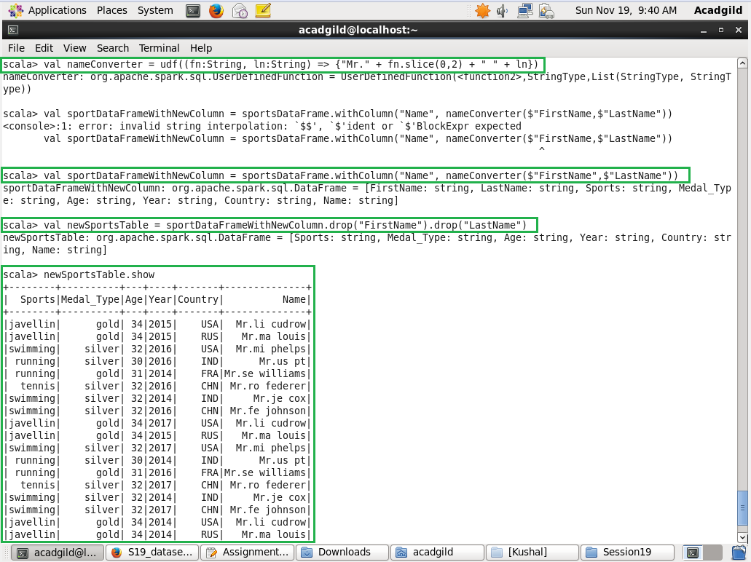

1. Add a new column called ranking using udfs on dataframe, where:

gold medalist, with age >= 32 are ranked as pro

gold medalists, with age <= 31 are ranked amateur

silver medalist, with age >= 32 are ranked as expert

silver medalists, with age <= 31 are ranked rookie

